# **Test Scenario**

**Sample system input and output**

BUSINESS PROCESS MODEL

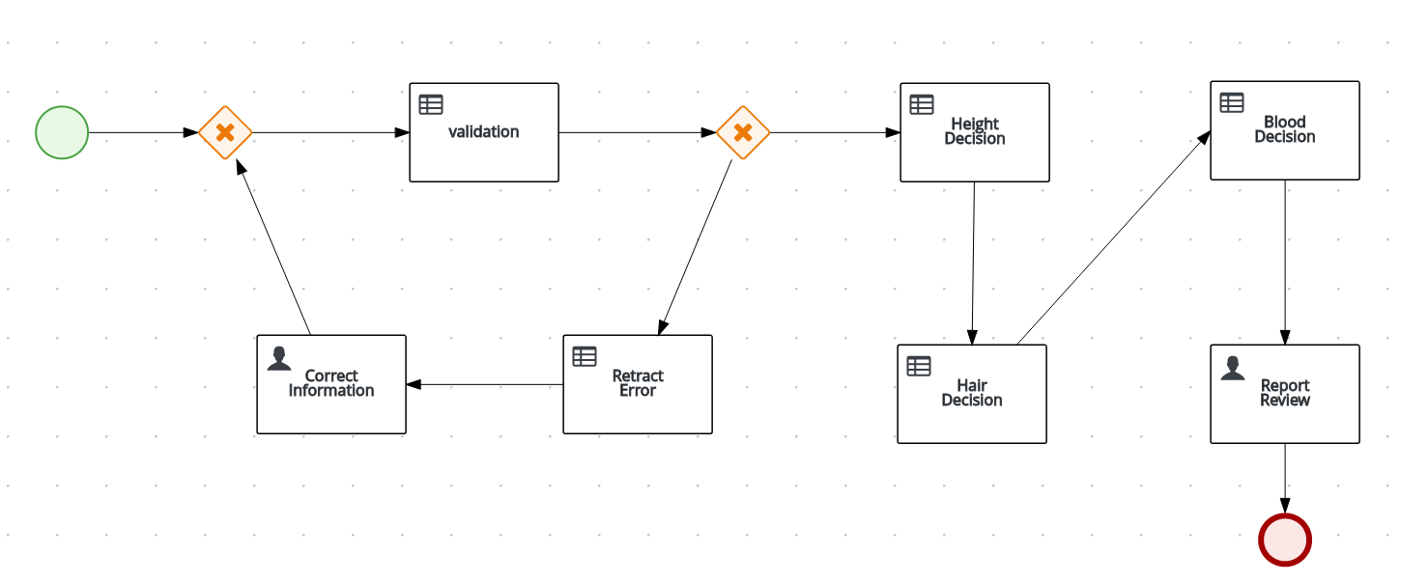

TEST SCENARIO

|  |  |
| --- | --- |
| Test Case 1 | Positive Test |
| User Input | Login as iss-sam |
| System out put | Login as iss-barry |

|  |  |
| --- | --- |
| Test Case 2 | Positive Test |
| User Input | Login as iss-sam |
| System out put | Login as iss-barry |

|  |  |
| --- | --- |
| Test Case 3 | Negative Test |
| User Input | Login as iss-sam |
| System out put | Login as iss-sam |